Working with Taxon Information

Working with Taxon Information 1
The General tab 2
The Common Name tab 2
The References tab 2
The Distribution tab 3
The Multimedia tab 4
The Associates tab 5
The Keywords tab 6
The Location tab 6
User-Defined Traits tab 7
User-Defined Notes tab 7
The higher rank Available Name details tab 8
The Genus Available Name details tab 8
Type species designation 9
General information 9
Type species information 9
Included species information 9
The Species Available Name details tab 10
General information 10
Type Data information 10
The Ownership tab 10
Entering distributions using the Region Explorer 11
Entering distributions using the Region Map 11
A note about changing the Region Map used by the Mapping Assistant 12
Using the Distribution Region Explorer 12
Adding new regions 13
Changing the position of a region 13
Transferring a region to the Favorites tab 13
Using the Location Explorer 13
Adding new locations 14
Changing the position of a location 14
Transferring a location to the Favorites tab 14
Storage Location Report 14
Managing Standard Phrases 15
Taxon Details window commands 15
Biota menu 15

Working with Taxon Information

BioLink manages a wide range of information about taxa. This information includes the following.
- Common Names: common names for a taxon and their sources
- References: references to published literature
- Distribution: the known distribution of a taxon based on political areas
- Multimedia: any file-based information, such as images, text documents, sound files and spread sheets, can be stored for a taxon
- Keywords: keywords which can be used to describe the taxon or used as search terms when retrieving information
- Associates: other taxa with which a taxon is known to be associated
- Storage Locations: the storage location of the taxon in a collection
- User-definable Traits and Notes.
- Nomenclatural Information: information on original publications and type specimens
This information is found on separate tabs of a single window: the Taxon Details window. To open this window, find the taxon of interest in the Taxon Explorer using Contents, Find or Favorites. Select the name of the taxon and click the right mouse button or open the Edit menu and select the Edit Taxon Details command. This will open the Taxon Details window containing information for the selected taxon. Details of this information follow. To set the tab that is displayed when the window initially opens use the Default Tab command on the Options menu.

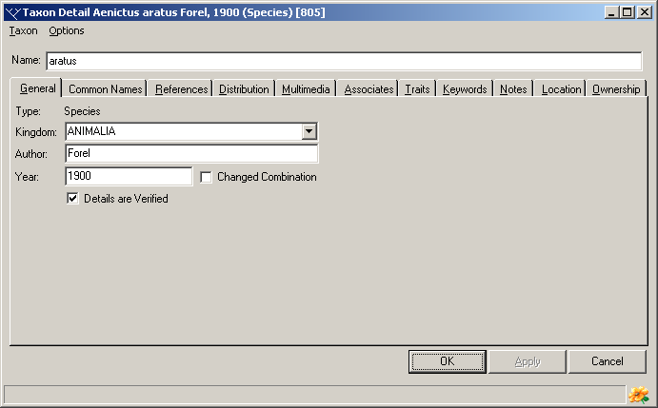
The General tab
The name of the taxon along with its author and year of publication is recorded here. In addition, the kingdom to which it belongs, its verified state and, for species, whether the name is changed combination, can also be recorded.

The Common Name tab
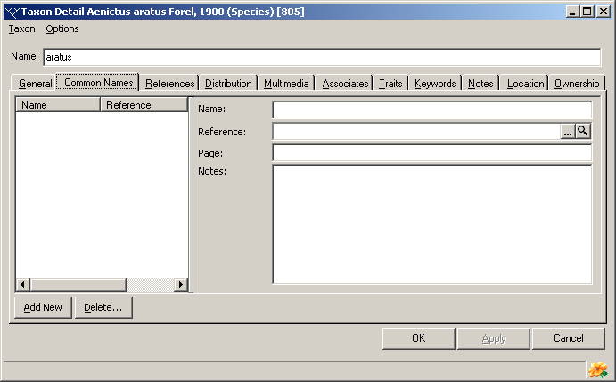
Any number of common names can be associated with a taxon. In addition to the common name, a literature reference (and page number) and notes about the name can be stored.
To add a new common name, press the Add New button near the lower left corner of the window. This will add a new entry to the list of common names on the left side of the window. Details for this name can then be entered in the fields on the right side of the window. To edit a previously entered common name select it in the list and edit its details on the right. To delete a name select it in the list and press the Delete button. Once changes have been made press the OK button to save changes and close the Taxon Details window or the Apply button to save changes and leave the window open. Pressing the Cancel button will close the window without saving changes.
The following items concerning common names can be stored.
Name: The common name of the taxon. This can be as long as required and can be composed of several words.
Reference: The Reference Code for a reference concerning this common name. To select a reference, press the ellipsis button (with the three dots) to the right of the field to open the Reference Manager. Locate the required reference and press the Reference Manager’s Select button. This will transfer the Reference Code to the Common Name tab. Alternately the Reference Code can be typed directly in the field. To see details of the selected reference press the Magnifying Glass button to the right of the Reference field. This will open the Reference Details window containing the selected reference.
Page: The page number within the reference relating to the common name.
Notes: Notes concerning the common name.

The References tab
Any number of references can be associated with a taxon. The type of each reference can be specified along with page number(s) and comments about the reference. By specifying a type, references can be grouped into sets of related references. Typical types might include Biology, Ecology, Taxonomy and Identification Guides.
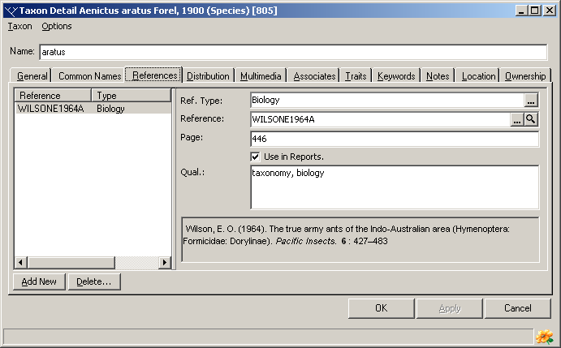
To add a new reference, press the Add New button near the lower left corner of the window. This will add a new entry to the list of references on the left side of the window. Enter the appropriate information to the fields on the right side of the window as outlined below. To edit a previously entered reference select it in the list and edit its details on the right. To delete a previously entered reference select it in the list and press the Delete key. Once changes have been made press the OK button to save changes and close the Taxon Details window or the Apply button to save changes and leave the window open. Pressing the Cancel button will close the window without saving changes.
The following items concerning references can be stored.
Reference Type: An indication of the type of this reference. This is used to group related references and as an indication of the nature of the reference. Specific types are user-defined and will commonly include such things as biology, taxonomy, identification, ecology and similar expressions.
Reference: The Reference Code for the reference concerning this taxon. To select a reference, press the ellipsis button (with the three dots) to the right of the field to open the Reference Manager. Locate the required reference and press the Reference Manager’s Select button. This will transfer the Reference Code to the References tab. Alternately the Reference Code can be typed directly in the field. To see details of the selected reference press the Magnifying Glass button to the right of the Reference field. This will open the Reference Details window containing the selected reference.
Page: The page number within the reference relating to the taxon.
Use In Reports: This option is used in combination with the Report Writer. It can be used to restrict the reporting of references only to those where Use In Reports has be selected.
Qualification: Notes concerning the reference.

The Distribution tab
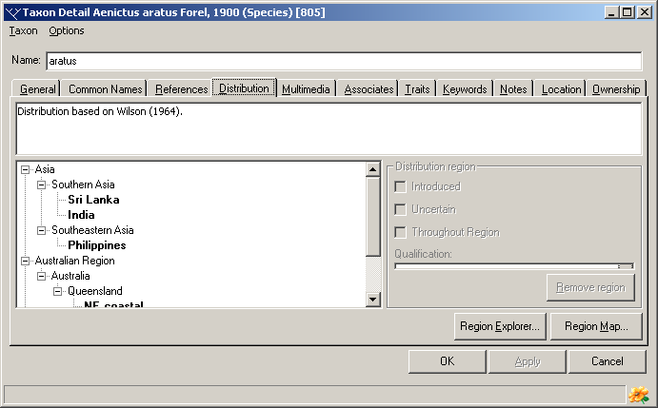
The Distribution tab is used to record information on the distribution of a taxon using political units (countries, states and the like). While this information will often be based on material records in a BioLink database it can also show distributions in regions lacking material records. This will often be the case when the taxon is known to be widespread (based on literature records, for example) and occurs outside areas where specimens have been collected (and databased).
The following information is recorded about taxon distributions:
General Notes: Assorted notes about the overall distribution of the taxon.
List of Regions: The list of regions where the taxon is known to occur. This list is hierarchical and items are added using the Region Explorer and Region Map (see below).
Introduced: An indication that the taxon has been introduced into the selected region.
Uncertain: An indication that the occurrence of the taxon in the selected region is uncertain.
Throughout Region: An indication that the taxon occurs throughout the selected region. This option is used when the selected region has subdivisions and the taxon is known to occur in all of these subregions. For example, if a taxon is known to occur throughout a country and that country has states, selecting the country and specifying Throughout Region is equivalent to directly selecting all states within the country. This means that when searching for taxa occurring in one of these states, the taxon would be returned as if the country was selected. If Throughout Region was not selected the taxon would not be returned (because it is interpreted as being known from somewhere in the country but not necessarily in any given state).
Qualification: Assorted notes on the selected region.
The Multimedia tab
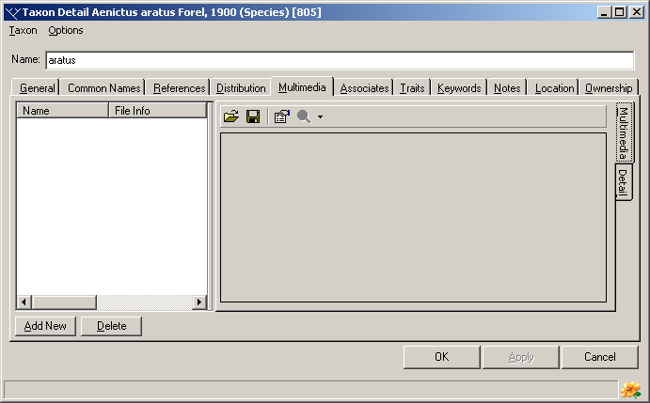
It is often necessary to associate electronically stored or file-based information with a taxon. BioLink terms this electronic (or digital) information ‘multimedia’. Multimedia can consist of image, sound or video files as well as text documents, spreadsheets or even databases. Any number of multimedia files can be stored for a taxon. In addition to the actual file, its type, name and caption can also be stored. These files are stored within the BioLink database rather than as links to local files found outside of BioLink. This ensures that this information is always present and reduces the chance of accidental deletion.
To add a new multimedia file, press the Add New button near the lower left corner of the window. This will create a new entry in the list on the left side of the window and open a File Open dialog box. Locate the file to be added and press OK. This will add the file to BioLink. Alternately, a file can be moved from the Windows Explorer or My Computer using Drag and Drop. Locate the desired file in the Windows Explorer or using My Computer and drag it onto either the Multimedia list or the preview window (on the lower right of the Multimedia window). Details for the file can be entered in the fields on the right side of the window. To edit information for a previously entered file, select it in the list and edit its details on the right. To delete a file, select it and press the Delete button. Once changes have been made press the OK button to save changes and close the Taxon Details window or the Apply button to save changes and leave the window open. Pressing the Cancel button will close the window without saving changes.
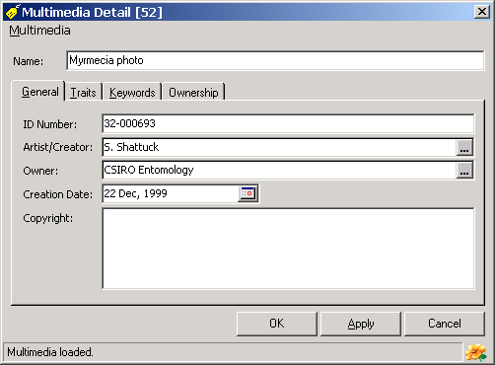
The Preview window, on the lower right of the window, will display a preview of most graphics files. If the selected file cannot be viewed a message will be displayed. To view these non-displayable files press the magnifying glass button on the toolbar. This will open the application associated with the file and automatically load the file. If no application is associated with the selected file a dialog will open asking the name of the application to use to view the file.
To replace an existing file with a new one select the old file in the list and press the first toolbar button (the button with the file folder icon). A File Open dialog box will be displayed allowing selection of the replacement file. To save an existing file to disk, select it in the list and press the second toolbar button (the button with a disk icon). A Save As dialog box will open where a new file name and path can be entered. To view properties of a given file press the third toolbar button (with the properties icon). This will open a window where details on an identification number, artist/creator, owner, creation date, copyright, traits and keywords can be entered.
The following items concerning multimedia can be stored.
Type: The type or class of the multimedia file.
Name: The name of the file.
Caption: A caption for the file as used with this taxon.
The following information can be stored for each multimedia item in the Properties window:
ID Number: A number assigned to this file
Artist/Creator: The name of the person who created the file.
Owner: The owner of the file.
Creation Date: The date the file was created.
Copyright: A copyright notice associated with the file.
Traits: User-defined traits for the file.
Keywords: Keywords associated with the file.

The Associates tab
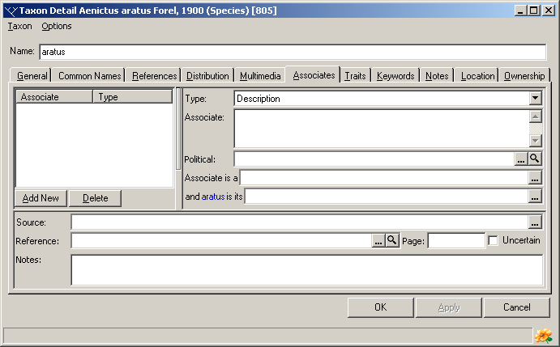
Within BioLink, ‘Associates’ are used to record the association or relationship between two taxa. This can involve relationships such as predator-prey or host-parasite. Any number of Associates can be recorded for a taxon.
To add a new Associate, press the Add New button near the lower left corner of the window. This will create a new entry in the list on the left side of the window. Details for the association can then be entered in the fields on the right side of the window. To edit a previously entered Associate select it in the list and edit its details on the right. To delete an Associate select it in the list and press the Delete button. Once changes have been made press the OK button to save changes and close the Taxon Details window or the Apply button to save changes and leave the window open. Pressing the Cancel button will close the window without saving changes.
The following items concerning associates can be stored.
Type: The Associate can be described in one of three ways: by a text-based description, by its taxonomic name as found in the Taxon Explorer, and by its Accession Number as found in the Site Explorer. These three options are described here.
Description: A description of the associate (most commonly its taxon name). This is used if the associate’s taxon is not in the Taxon Explorer and it does not have a Material record in the database.
Taxon: The taxon name of the associate. Names are transferred from the Taxon Explorer using drag and drop or the Select button and can be at any rank. To open the Explorer press the ellipsis button to the right of the Identification field. This is used if there is not a Material record for this associate.
Material: The name of the material record of the associate. This is used when the associate has been recorded in the database. The Material name is transferred from the Site Explorer using drag and drop or the Select button. To open the Explorer press the ellipsis button to the right of the Material field.
Associate is a: The type of relationship between the associate and this specimen (from the perspective of the associate). For example, the associate is the parent of its child (the specimen).
...is its: The type of relationship between the specimen and its associate (from the perspective of the specimen). For example, the material represents the child of its parent (the associate).
Source: The source of this associate information (for example literature, observation, material).
Reference, Page: A link to a reference (and page) if this information is based on the literature.
Uncertain: An indication that this information is uncertain.
Notes: Assorted notes about the associate.

The Keywords tab
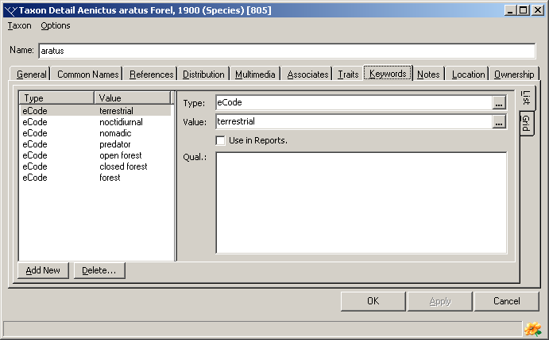
Keywords are used to describe features of taxa. They are similar to Traits but differ in that any number of values can be assigned to a single keyword type while a given Trait can have only a single value. This gives greater flexibility where multiple values are needed to describe a feature. For example, a taxon may occur in a range of habitats such as rainforest, heath and grasslands. The keyword type ‘habitat’ can be used for this feature, with three records being created, one each for ‘rainforest’, ‘heath’ and ‘grassland’. These terms can then be used in reports and during searching.
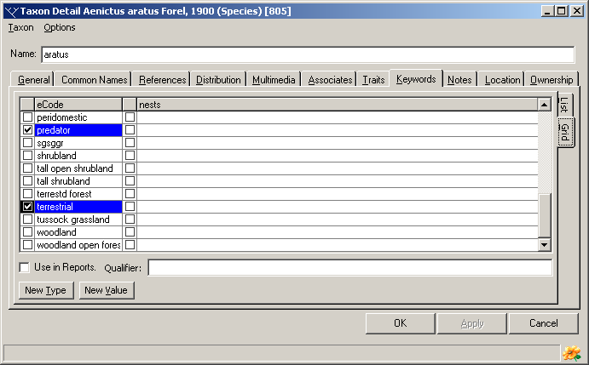
Keywords can be entered using two methods, a list or a grid. These methods are selected using a tab on the right side of the Keywords tab.
Using the List
To add Keywords using the list click the List tab and then press the Add New button near the lower left corner of the page. This will open a window with a list of previously created Keyword types. Select a existing Keyword type or create a new one using the Add New button near the bottom of the list. Press the OK button on the Keyword window to create the new Keyword type and copy it to the taxon window. The value for this new Keyword can then be entered in the Value field on the right side of the Keywords tab. A comment concerning this Keyword can also be included and the Use in Reports checkbox ticked if it is to be used in reports. To delete a Keyword select it in the list and press the Delete button. Pressing the OK button will save changes and close the Taxon Details window while pressing the Apply button will save changes but leave the window open.
Using the Grid
To add Keywords using the grid click the Grid tab. This will open a panel with the keyword types listed across the top of the columns and their keyword values listed below them (preceded by check boxes). Previously entered keywords will be checked and highlighted. To select keywords click on the checkbox to the value's right. To unselect a keyword clear this checkbox. To add a new type of keyword press the New Type button near the bottom left of the screen. This will open a window with a list of previously created Keyword types. Press the Add New button near the bottom of the list and enter the name of the new type. To add a new value to a keyword type press the New Value button and enter the new value in the grid. To change the name of an existing value double-click on it in the grid and type its new name. When all values have been selected (and are highlighted) press the OK button to save changes and close the Taxon Details window or press the Apply button to save changes but leave the window open.

The following keywords information can be recorded:
Type: The type or class of the keyword.
Value: The value assigned to this keyword.
Use In Reports: This option is used in combination with the Report Writer. It can be used to restrict the reporting of keywords to only those where Use In Reports has be selected.
Qualification: A comment about this keyword.

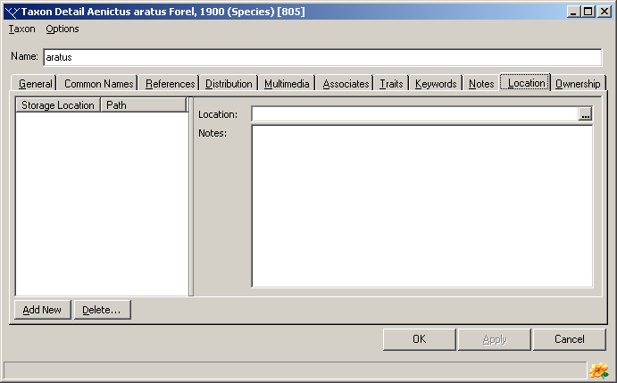
The Location tab
The Location tab is used to record information on the storage location of a taxon within a collection. This information can be especially useful in large collections or in cases where a single taxon is stored in multiple locations (for example, when alcohol material is stored separately from dried material).
To add a new storage Location, press the Add New button near the lower left corner of the window. This will add a new entry to the list of Locations in the list on the left side of the window. The actual storage location is entered using the Location Explorer (see Using the Location Explorer below). Click the ellipsis button (with the three dots) to the right of the Location field to open this Explorer. Locate the required location in the Explorer and press the Select button. This will transfer the location to the Taxon Details tab. Add notes about this location in the Notes field if required. To edit a previously entered Location, select it in the list and edit its details on the right. To delete a previously entered Location, select it in the list and press the Delete button. Once changes have been made press the OK button to save changes and close the Taxon Details window or the Apply button to save changes and leave the window open. Pressing the Cancel button will close the window without saving changes.

User-Defined Traits tab
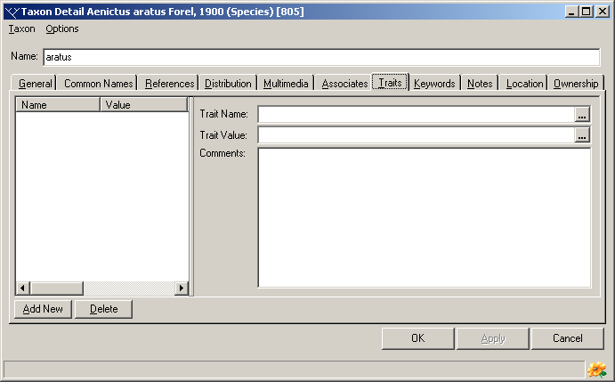
BioLink supports information that is common across most taxonomic groups and scientific disciplines. However, specific taxa and disciplines will need to manage additional information not directly supported by BioLink. This information includes such things as measurements of specimens, details of storage methods (for example position on microscope slides) or environmental characteristics such as nest sites, soil types or weather conditions. The list of these sorts of data elements is almost limitless.
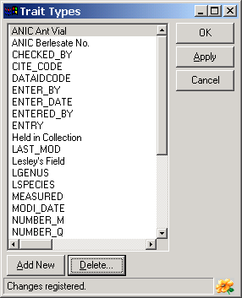
To address this problem, BioLink supports Traits and Notes. Traits are used to store information about items that are not found in other BioLink windows. They allow the storage and reporting of a wide range of items that are taxon or project specific, or that are required for a specific report but are not generally required for most activities. In essence, Traits allow the addition of new fields when and where required.
To add a new Trait press the Add New button near the lower left corner of the window. This will open a window with a list of previously used Trait types. Select an existing Trait from the list or create a new one using the Add New button near the bottom of the list. Press the OK button on the Trait window to create the new Trait and copy it to the Taxon Details window. The value for this new Trait can then be entered in the Trait Value field on the right side of the Traits tab. A comment concerning this Trait can also be included. To delete a Trait, select it in the list and press the Delete button. Once changes have been made press the OK button to save changes and close the Taxon Details window or the Apply button to save changes and leave the window open. Pressing the Cancel button will close the window without saving changes.

User-Defined Notes tab
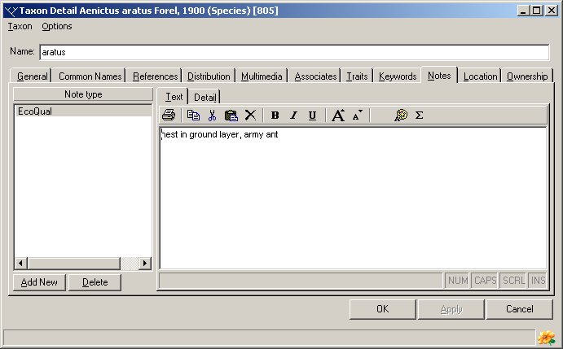
Notes are essentially the same as Traits except they are used to store text-based information. They can be of any length, can contain font and paragraph formatting (such as bold, italics, underlining, font type, size and colour, justification and hanging indents) and any number of Notes can be created for a taxon. Notes can also contain embedded graphics.
To add a new Note press the Add New button near the lower left corner of the window. This will open a window with a list of previously used Note types. Select an existing Note or create a new one using the Add New button near the bottom of the list. Press the OK button on the Note window to create the new Note and copy it to the taxon window. The text for this new Note can then be entered in the right side of the Notes tab. To format text, including bold, italics, underlining, font size and font colour, select the text and use the buttons on the toolbar. Symbols can be entered by pressing the sigma button. The Note text can be printed and copied or cut to the clipboard using toolbar buttons, and the contents of the Clipboard can be added to a Note using the Paste button.
Once changes have been made press the OK button to save changes and close the Taxon Details window or the Apply button to save changes and leave the window open. Pressing the Cancel button will close the window without saving changes.

The higher rank Available Name details tab
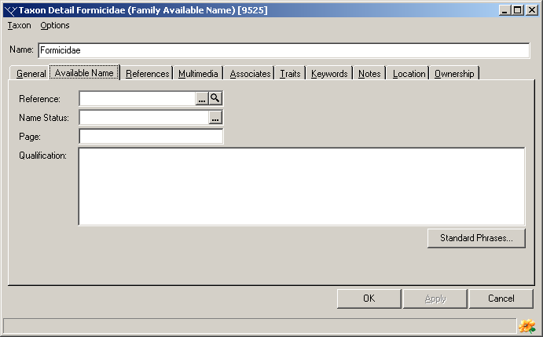
Nomenclatural details for available names above the rank of genus are recorded on the Available Name tab of the Taxon Details window. This information can only be entered for available names. The following information can be recorded:
Reference: The Reference Code for the reference where the name was made available. To select a reference, press the ellipsis button (with the three dots) to the right of the field to open the Reference Manager. Locate the required reference and press the Reference Manager’s Select button. This will transfer the Reference Code to the Available Name tab. Alternately the Reference Code can be typed directly in the field. To see details of the selected reference press the magnifying glass button to the right of the Reference field. This will open the Reference Details window containing the selected reference.
Page: The page number within the reference relating to the name.
Name Status: The current status of the name, for example 'valid', 'junior synonym', 'homonym'.
Qualification: Notes concerning the name.
To reduce data entry time and increase data consistency, a list of standard phrases can be established. These phrases are accessed by pressing the Standard Phrases button. This will open a window with a list of previously entered phrases. Select a phrase and press the OK button to transfer the phrase to the Qualification field of the Taxon Details window. See Managing Standard Phrases below for additional information concerning Standard Phrases.
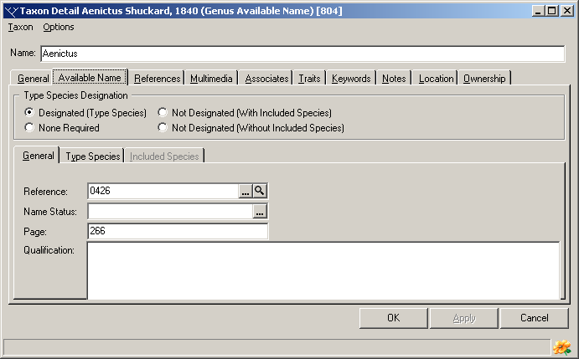
Once data has been entered press the OK button to save changes and close the Taxon Details window or the Apply button to save changes and leave the window open. Pressing the Cancel button will close the window without saving changes.

The Genus Available Name details tab
Nomenclatoral details for available names at the genus level are recorded on the Genus Available Name tab of the Taxon Details window. This information is organised into four sets: Type Species Designation, General information, Type Species information and Included Species information. This information can only be entered for available names.

Type species designation
The nature of the type species designation is selected from four options listed in a box near the top of the window. These include the following:
Designated (Type Species): A type species has been designated. Its details can be entered on the Type Species tab.
None Required: A type species is not required for this available name (for example, a new replacement name does not require a type species to be designated).
Not Designated (With Included Species): A type species has not been designated and species were included when the name was originally proposed. The included species are listed on the Included Species tab.
Not Designated (Without Included Species): A type species has not been designated and species were not included when the name was originally proposed.

General information
The following general information concerning genus group available names can be recorded.
Reference: The Reference Code for the reference where the name was made available. To select a reference, press the ellipsis button (with the three dots) to the right of the field to open the Reference Manager. Locate the required reference and press the Reference Manager’s Select button. This will transfer the Reference Code to the Available Name tab. Alternately, the Reference Code can be typed directly in the field. To see details of the selected reference press the magnifying glass button to the right of the Reference field. This will open the Reference Details window containing the selected reference.
Page: The page number within the reference relating to the name.
Name Status: The current status of the name, for example 'valid', 'junior synonym', 'homonym'.
Qualification: Notes concerning the name.
To reduce data entry time and increase data consistency, a list of standard phrases can be established. These phrases are accessed by pressing the Standard Phrases button. This will open a window with a list of previously entered phrases. Select a phrase and press the OK button to transfer the phrase to the Qualification field of the Taxon Details window. See Managing Standard Phrases below for additional information concerning Standard Phrases.

Type species information
The name of the type species is entered on the Type Species tab. The name can be entered in any format required (for example, its original combination and spelling followed by the combination and spelling used when designated). This field supports italics and bold by selecting text and pressing the Ctrl+I and Ctrl+B keys, allowing text to be formatted as required.
The method of fixation of the name can be entered in the box along the bottom of the window. To open a list of phrases for methods of fixation press the ellipsis button (with the three dots) to the right of the box.

Included species information
If a genus was established without designating a type species but including a list of species placed in the genus, these species can be listed on the Included Species tab. To add a new included species, press the Add New button near the lower left corner of the window. This will create a new entry in the list on the left side of the window. Details for this species name can then be entered in the fields on the right side of the window. To edit a previously entered name select it in the list and edit its details on the right. To delete a name select it in the list and press the Delete button.
Once data has been entered press the OK button to save changes and close the Taxon Details window or the Apply button to save changes and leave the window open. Pressing the Cancel button will close the window without saving changes.

The Species Available Name details tab
Nomenclatoral details for available names at the species level are recorded on the Species Available Name tab of the Taxon Details window. This information can only be entered for available names. The information is organised into two sets: General information and Type Data information.

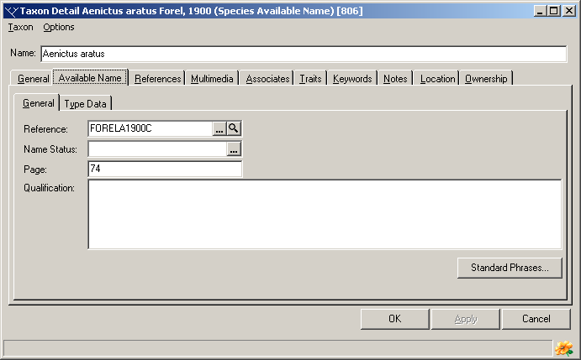
General information
The following general information concerning species group available names can be recorded.
Reference: The Reference Code for the reference where the name was made available. To select a reference, press the ellipsis button (with the three dots) to the right of the field to open the Reference Manager. Locate the required reference and press the Reference Manager’s Select button. This will transfer the Reference Code to the Available Name tab. Alternately, the Reference Code can be typed directly in the field. To see details of the selected reference press the magnifying glass button to the right of the Reference field. This will open the Reference Details window containing the selected reference.
Page: The page number within the reference relating to the name.
Name Status: The current status of the name, for example 'valid', 'junior synonym', 'homonym'.
Qualification: Notes concerning the name.
To reduce data entry time and increase data consistency, a list of standard phrases can be established. These phrases are accessed by pressing the Standard Phrases button. This will open a window with a list of previously entered phrases. Select a phrase and press the OK button to transfer the phrase to the Qualification field of the Taxon Details window. See Managing Standard Phrases below for additional information concerning Standard Phrases.

Type Data information
The following type data information can be recorded for a species:
Primary Type: The nature of the primary type. This is selected from a picklist. The Probable checkbox can be ticked if the exact nature of the type is uncertain.
Secondary Type: The nature of secondary type(s). This is selected from a picklist. Note that selection of the primary type will restrict the choices available for the secondary type. For example, if the primary type is a holotype then the secondary type must be a paratype. The Probable checkbox can be ticked if the exact nature of these types is uncertain.
Specimen Details: Details concerning the actual type specimen(s) are recorded in the lower section of the Type Data window. To add a new specimen, press the Add New button near the lower left corner of the window. This will create a new entry in the list on the left side of the window. Details for this specimen can then be entered in the fields on the right side of the window. To edit a previously entered specimen, select it in the list and edit its details on the right. To delete a specimen, select it in the list and press the Delete button.
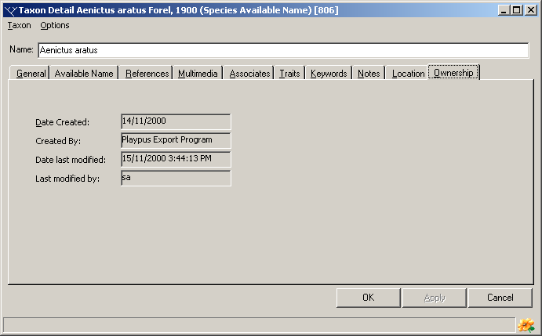
Once data has been entered press the OK button to save changes and close the Taxon Details window or the Apply button to save changes and leave the window open. Pressing the Cancel button will close the window without saving changes.

The Ownership tab
This tab contains information on the person who created the current record as well as the person who most recently modified it. The following information is included.
Date Created: The date and time the current record was originally created.
Created By: The username of the person creating the record.
Date last modified: The date and time the record was last updated.
Last modified by: The username of the person last updating the record.

Entering distributions using the Region Explorer
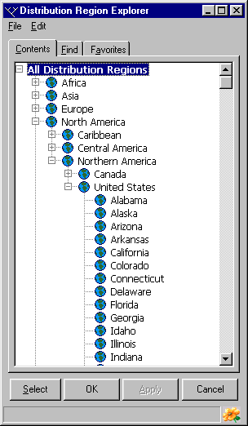
The Distribution Region Explorer contains a complete list of all regions found in a database. New regions can be added using this Explorer as well as being renamed and deleted. Regions are organised hierarchically, any number of hierarchical levels can be used and regions can be selected from any level in the hierarchy. The Explorer has Contents, Find and Favorites that function in the same way as their counterparts in the Taxon Explorer and Site Explorer. See Using the Distribution Region Explorer below for further details.
To add a political region to the distribution of a taxon find the required region using Contents, Find or Favorites. Once located, select the region and press the Select button or drag the region and drop it onto the Taxon Details window. This will add the region to the taxon and update the Taxon Details window. Once added, select the region to change the Introduced, Uncertain and Throughout Region settings and to add notes about the region. To delete the selected region press the Remove Region button.
Note that when a region is added to a taxon all of the region’s parents are also transferred to the Distribution list. Regions that were selected are displayed in bold while those that were automatically transferred are displayed in normal font. Also, details (Introduced, Uncertain, Throughout Region and Notes) can only be added for regions that have been selected, and only these regions can be deleted from the Distribution list.

Entering distributions using the Region Map
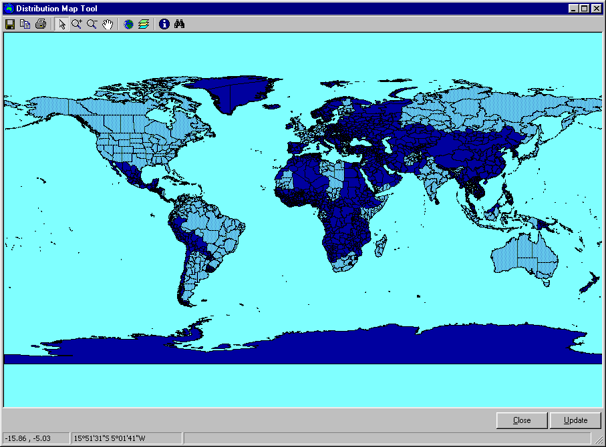
An alternative way to enter distribution information is to use the Mapping Assistant in combination with specially constructed Shape files. These special Shape files contain three fields (in their dbf files) not found in normal Shape files. These three fields are BLRegion, which contains the name of the region, BLRegHier, which contains the complete hierarchy for the region and BLAuth, the author of the region. Any standard Shape file can be used to enter distribution information by adding these three fields and filling them with the required information. In addition, all of the normal Mapping Assistant functions are available while entering distribution information, including zooming, the use of multiple layers and the setting of user-specified colours and patterns. When opened from the Taxon Details window, the Mapping Assistant contains an extra toolbar button, the Find button as well as Close and Update buttons. A selection of Shape files designed for recording distributions are found in the Region Layers folder in the Map Layers folder in the directory where BioLink was installed.
To open the Mapping Assistant preloaded with the most recently opened region-based Shape file, press the Region Map button on the Distribution tab. Once loaded, previously recorded distribution information for the currently selected taxon will be scanned and loaded into the Mapping Assistant. The selected regions will be highlighted while unselected regions will remain in the normal colour specified in the Layers window (see Mapping Assistant for further details). To add new regions or delete existing regions from the distribution list of the taxon, simply click on the region of interest with the mouse pointer. The map will be updated to show the new distribution pattern. Once the map has been updated to show the new distribution pattern, press the Update button to transfer this information to the Distribution tab of the Taxon Details window. To abandon changes and close the Mapping Assistant press the Close button.
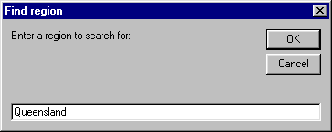
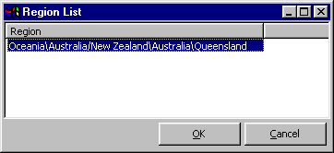
The Find button (the button with the binocular icon on the right end of the toolbar) can be used to search for a region within the map. Press this button to open the Find Region window. Enter the name of a region and press OK. There is no need to use wildcards as they are automatically added before and after the name entered. The Region List window will open filled with a list of regions matching the request. Note that the name of the region can be at any level in the hierarchy, with higher regions returning the region and all of its children. To add a region to the distribution of the taxon, select the region in the list and press the OK button. The region will be located and highlighted in the Mapping Assistant and the Region List window will close.
To select multiple regions in an area place the mouse pointer over the area of interest and press the right mouse button. This will open a menu showing each level in the region hierarchy as a menu item with the highest or broadest region at the top of the list and the lowest or narrowest region at the bottom. Selecting one of these items will select and highlight it and all of its children in the Mapping Assistant.

A note about changing the Region Map used by the Mapping Assistant
BioLink stores the names of regions and their hierarchical placement but it does not store the Shape file used to enter this information (the information is stored, however, in the Region Explorer). This means that if a different Shape file is used some of the regions present for a taxon may not be present in the Shape file. In these cases regions previously coded for the taxon may not be displayed on the selected map. In other cases, a different region may be displayed. For example, if a state was originally selected (which contained its country as well) and the new Shape file only contains country names (and not state names), this new map will have the entire country highlighted rather than just the state as originally recorded. The advantage of this system is that a given set of distribution information can be presented a number of ways simply by changing the regions found in a Shape file without having to recode information for a taxon. It also means that multiple geographic hierarchies or coding systems can be simultaneously maintained by using a series of Shape files each with different regions. The disadvantage is that caution needs to be used when changing the Shape file used to display distribution information.

Using the Distribution Region Explorer
The Distribution Region Explorer graphically displays the names of all political regions used to describe the distribution of taxa. The Explorer is opened using the Region Explorer button on the Distribution tab of the Taxon Details window. It can also be opened under the Taxon button on the main BioLink toolbar.
The Taxon Explorer has three tabs: Contents, Find and Favorites.
The Contents tab contains a complete, hierarchical listing of all political regions. When first opened, the Explorer shows only the top-most or most general region. Clicking the small plus symbol before a region will expand the tree and show all of the children or next-level regions found below the selected region.
The Find tab can be used to locate any region in the database. Enter the required name in the upper box and press the Find button. A list of names matching the request will be displayed. To find names containing a subset of characters, enter an asterisk wildcard (*) as the first character or between other characters (a wildcard is automatically added to the end of all requests). Once a search has been completed, a region can be found in the full list (on the Contents tab) by selecting the name, clicking the right mouse or opening the Edit menu and selecting the Find Entry in Contents command.
The Favorites tab can be used for easy access to commonly used regions. Regions are transferred from the Contents and Find tabs to the Favorites tab (see below for details) and all actions available from the Contents and Find tabs, such as adding and deleting regions, can be preformed from the Favorites tab.

Adding new regions
To add a new region to the Explorer, select the parent of the new region (the region to which the new one belongs) and click the right mouse button or open the Edit menu and select the Add Region command. This will add a new region to the Explorer. Replace the default region name with the new one and press Enter. Pressing the Apply button near the bottom of the Explorer will save the newly added region to the database. To change a region’s name select it, click the right mouse button or open the Edit menu and select the Rename command. The name can then be edited as required and updated by pressing the Enter key.

Changing the position of a region
Changing the position of a region is accomplished by finding it in the Explorer and using drag and drop to move it into its new position. Regions can also be combined using the same drag and drop technique. A message will be displayed giving the option to change the position of the dragged region or to merge the data for the region with the region being dropped onto.

Transferring a region to the Favorites tab
To transfer a region from the Contents or Find tabs to the Favorite tab, first locate and select the required region and then click the right mouse button or open the Edit menu. Select the Transfer Item to Favorites command followed by either the User Specific or Global command. User Specific favorites will only be available to the user who created them, while global favorites will be available to all users of the database. Note that Favorites are copies of the items found on the Contents and Find tabs and any changes made to them on the Favorites tab, whether user specific or global, will be save to the BioLink database and will be seen by all users of these items. Thus caution should be used when making changes to Favorites as these will have the same affect as making changes directly on the Contents tab. Copying regularly used taxa to the Favorites tab will reduce the need to search for names and speed access to commonly used information.
Once changes have been made press the OK button to save changes and close the Taxon Details window or the Apply button to save changes and leave the window open. Pressing the Cancel button will close the window without saving changes.

Using the Location Explorer
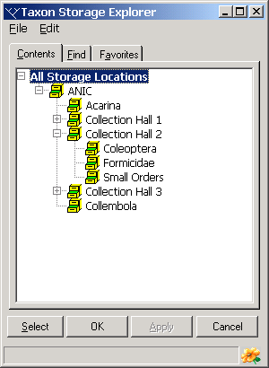
The Location Explorer is used to graphically manage storage locations within a collection or institution. Individual locations are organised hierarchically and can have any number of levels or amount of detail. This means that a location can be defined as broadly as a building, or as detailed as a slide in a box in a drawer in a cabinet in a room on a floor in a building at a site in a city in a county in a state in a country on a continent (whew!).
The Location Explorer has three tabs: Contents, Find and Favorites.
The Contents tab contains a complete, hierarchical listing of all storage locations. When first opened, the Explorer shows only the top-most or most general locations. Clicking the small plus symbol before a location name will expand the tree and show all of the children or next-level locations found below the selected location.
The Find tab can be used to locate any location in the database. Enter the required name in the upper box and press the Find button. A list of names matching the request will be displayed. To find names containing a subset of characters, enter an asterisk wildcard (*) as the first character or between other characters (a wildcard is automatically added to the end of all requests). Once a search has been completed, a location can be found in the full list (on the Contents tab) by placing the mouse pointer over the name, clicking the right mouse and selecting the Find Entry in Contents command.
The Favorites tab can be used for easy access to commonly used locations. Locations are transferred from the Contents and Find tabs to the Favorites tab (see below for details) and all actions available from the Contents and Find tabs, such as adding and deleting locations, can be preformed from the Favorites tab. User Favorites belong to individual users so only those locations of interest are present to each user (Global Favorites are available to all users).

Adding new locations
To add a new location to the Explorer, place the mouse pointer on the parent of the new location (the location to which the new one belongs), click the right mouse button or open the Edit menu and select the Add Storage Location command. This will add the new location to the Explorer. Replace the default location name with a new one and press Enter. Pressing the Apply button near the bottom of the Explorer will save the newly added location. To change a location’s name place the mouse pointer over the name, click the right mouse button or open the Edit menu and select the Rename command. The name can then be edited as required and updated by pressing the Enter key.

Changing the position of a location
Changing the position of a location is accomplished by finding it in the Explorer and using drag and drop to move it into its new position. Locations can also be combined using the same drag and drop technique. A message will be displayed giving the option to change the position of the dragged location or to merge the data for the location with the location being dropped onto.

Transferring a location to the Favorites tab
To transfer a Location from the Contents or Find tabs to the Favorites tab, first locate the required location. Place the mouse pointer over the item and click the right mouse button or open the Edit menu. Select the Transfer Item to Favorites command followed by either the User Specific or Global command. User Specific favorites will only be available to the user who was logged on at the time they were created while global favorites will be available to all users of the database. Note that Favorites are copies of the items found on the Contents and Find tabs and any changes made to them on the Favorites tab, whether User Specific or Global, will be saved to the database and will be seen by all users of these items. Thus caution should be used when making changes to Favorites as these will have the same affect as making changes directly on the Contents tab. Copying regularly used Locations to the Favorites tab will reduce the need to search for names and speed access to commonly used information.
Once changes have been completed, press the OK or Apply buttons to save this information or the Cancel button to exit without saving. Pressing the OK button will save changes and close the Explorer while pressing the Apply button will save changes but leave the window open.

Storage Location Report
The Storage Location Report provides a text-based report of the taxa stored in the currently selected Location Explorer area. To open this report, select an area in the Location Explorer, click the right mouse button or open the Edit menu and select the Taxa for Storage Location List command. A dialog box will open where the location can be changed and the taxa to be included specified (if required). To change the location or to specify taxa, press the ellipsis button (with the three dots) to the right of the Location or Taxon field. This will open the appropriate Explorer where a new location or taxon can be located and transferred to the dialog box using the Explorer’s Select button or drag and drop. Once these items are properly set, press the Preview button. This will open a window containing a list of all taxa stored in the selected area.
Information in the report can be copied to the clipboard by selecting the text to be copied and pressing Ctrl+C or using the Copy command from the Edit menu. The entire report can be saved to disk (in RTF: rich text format) by pressing the first toolbar button or selecting the Save As command from the File menu. This will open a Save As dialog box where a file name can be specified. To print the report press the second toolbar button or select the Print command from the File menu.

Managing Standard Phrases
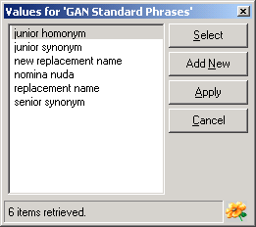
Standard Phrases are provided as an aid to standardising the qualifications of available names (for higher order, genus-group and species-group names). Phrases are selected from a window that is opened by pressing the Standard Phrases button on the Taxon Details window. To transfer a Phrase, select it in the list and press the Select button. To add a new Phrase, press the Add New button and replace the default text <New Item> with the text of the new phrase. Press the Apply button to save changes. To close the window, press the Cancel button.

Taxon Details window commands

Biota menu
Save/Apply: This command saves any changes made in the Taxon Details window to the database. It is equivalent to pressing the Apply button near the bottom of the window.
Close: Selecting the Close command will close the window without and any unsaved changes will be lost.

